October 13th, 2020
Dear Parents/Guardians,

Over the past several years, the Ministry of Education has mandated districts to implement the new B.C Curriculum. As a result, the way we deliver education and how we communicate the learning of students has also been changing. This year, students in grades K-7 will continue to receive descriptive feedback throughout the year and a proficiency rating in place of letter grades on two summary of learning reports. Summary of learning reports will be sent home twice a year. Once at the end of January and again in June.

A proficiency scale describes where a student presently is in reference to broadly held expectations for a specific grade level.
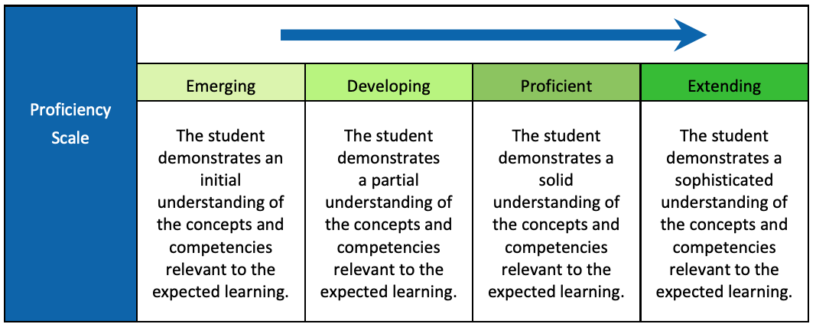

To add greater meaning to the proficiency ratings, you will receive ongoing descriptive feedback about your student’s learning through digital or paper-based points of progress. Teachers will provide points of progress based on the table below, with 3-6 communications being completed by the end of January.

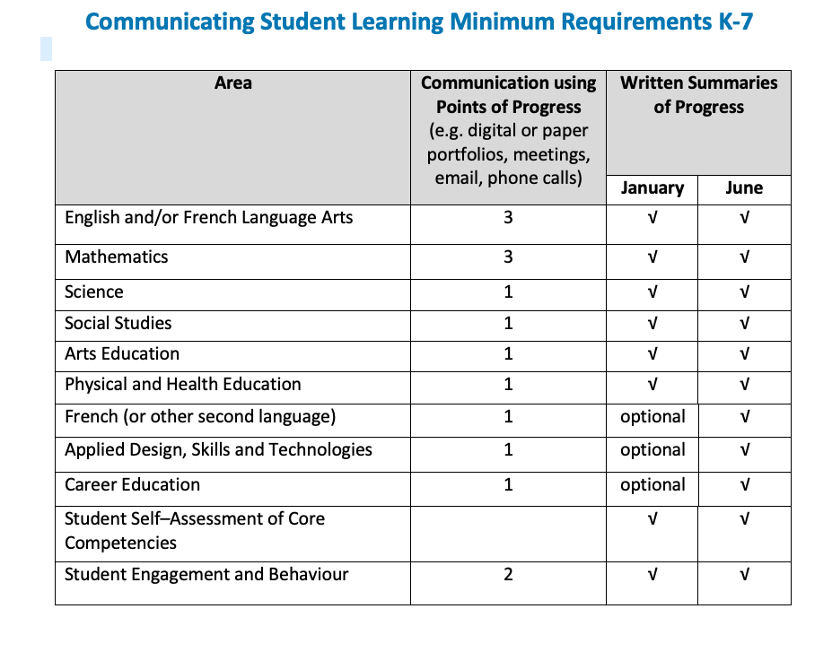
A point of progress has four key components:
Authentic Evidence of Learning
- A clear description of what the learner is doing, that includes the learning intention/goal.
  - Photos, videos, audio and work samples that offer visible authentic evidence of learning and bring learning to life.
Descriptive Feedback
- Detailed information about what the learner is doing well, and what needs improvement.
Next Steps
- A clear description that indicates what the next steps are in order for learning to progress further.
  - They may be written as a goal statement from the student or teacher in relation to the learning intention and evidence.
  - They may also describe how the next steps may be supported.
- Teachers may also provide sample question prompts for parents to engage with their child regarding the learning sample.
Student Voice
- Student reflections on their learning, and how they connect to the learning intentions, learning standards and/or next steps.
- Students may include evidence of learning captured outside of school time.
The above may be achieved through digital portfolios, paper portfolios, email, phone calls, face-to-face meetings or in combination.

For digital portfolios, the district officially supports the Ed Inform App which aligns with the requirements shared above, allows points of progress to be connected to summaries of learning and is the place where parents may review IEP information and evidence of growth related to specific goals.

Yours truly,

